**American International University-Bangladesh (AIUB)**

**Department of Computer Engineering**

COE 3201: Data Communication Laboratory

**Lab Report 1**

**Title: Introduction to MATLAB**

**Supervised By**

**SADMAN SHAHRIAR ALAM**

## Submitted By

|  |  |
| --- | --- |
| **Name** | **ID** |
| **RIFAH SANZIDA** | **22-47154-1** |

## Group Members

|  |  |
| --- | --- |
| **Name** | **ID** |
| **MD. JOBAER HOSSAIN** | **22-47116-1** |
| **MD SAMIN YEASAR** | **22-47139-1** |
| **SHAYAN ABRAR** | **22-47156-1** |

**Ans the questions**

**ID: AB-CDEFG-H**

**ID: 22-47154-1**

**a**

A1 = 22;  
A2 = 41;  
j1_deg = 74;  
j2_deg = 30;  
CDEF= 4715; % Frequency in Hz

% Convert degrees to radians  
j1 = deg2rad(j1_deg);  
j2 = deg2rad(j2_deg);

 % Time vector  
T = 1 / f; % Period of the wave  
t=-1:0.01:+1; % Adjust the time range and number of samples as needed

% Generate x1(t) and x2(t)  
x1 = A1 * cos(2 * pi * f * t + j1);  
x2 = A2 * cos(2 * pi * f * t + j2);

**b**

A1=4;

A2=5;

f=17;

j1=0.192;

j2=0.524;

t=-1:0.01:+1;

x1=A1*sin(2*pi*f*t+j1);

subplot(2,1,1)

plot(t,x1)

xlabel('Time in Second');

ylabel('Amplitude in Volt');

title('Signal x1(t)');

x2=A2*sin(2*pi*f*t+j2);

subplot(2,1,2)

plot(t,x2)

xlabel('Time in Second');

ylabel('Amplitude in Volt');

title('Signal x2(t)');

c

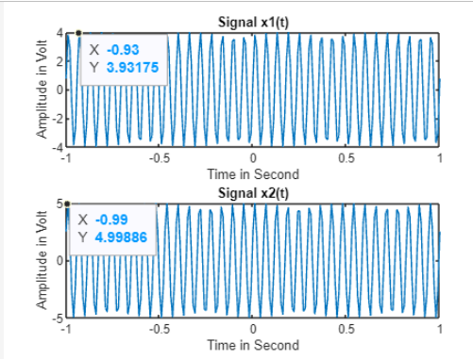

x1(t) at t = 0: 3.926  
Amplitude:4  
Phase (radians): 0.192  
   
x2(t) at t = 0: 4.329  
Amplitude: 5  
Phase (radians): 0.524

**d**

A1=4;

A2=5;

f=17;

j1=0.192;

j2=0.524;

t=-1:0.01:+1;

x1=A1*sin(2*pi*f*t+j1);

subplot(3,1,1)

plot(t,x1)

xlabel('Time in Second');

ylabel('Amplitude in Volt');

title('Signal x1(t)');

x2=A2*sin(2*pi*f*t+j2);

subplot(3,1,2)

plot(t,x2)

xlabel('Time in Second');

ylabel('Amplitude in Volt');

title('Signal x2(t)');

subplot(3, 1, 3);

bar([abs(x1), abs(x2)]);

title('Amplitudes at t = 0');

ylabel('Amplitude');

xticklabels({'x1(t)', 'x2(t)'});

sgtitle('Signal Plots and Amplitudes at t = 0');

**e**

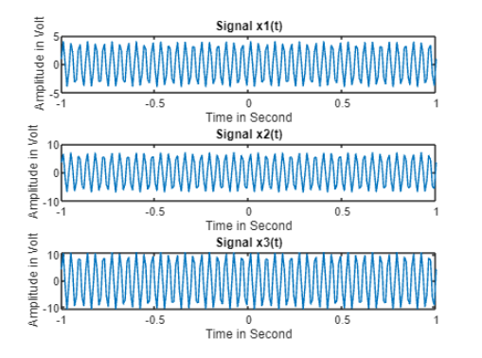

A1=4;

A2=5;

f=17;

j1=0.192;

j2=0.524;

t=-1:0.01:+1;

x1=A1*sin(2*pi*f*t+j1);

subplot(3,1,1)

plot(t,x1)

xlabel('Time in Second');

ylabel('Amplitude in Volt');

title('Signal x1(t)');

x2=A2*sin(2*pi*f*t+j2);

subplot(3,1,2)

plot(t,x2)

xlabel('Time in Second');

ylabel('Amplitude in Volt');

title('Signal x2(t)');

x3=x1+x2;

subplot(3,1,3)

plot(t,x3)

xlabel('Time in Second');

ylabel('Amplitude in Volt');

title('Signal x3(t)');

|  |
| --- |
|  |

**f**